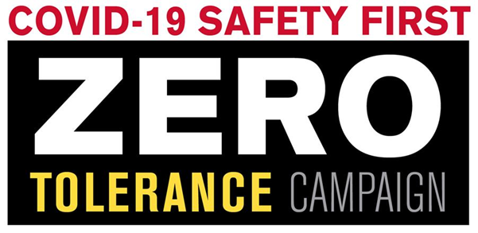

|  |
| --- |
| **​Lives and Livelihoods are at Risk** |
| **CONTRACTORS URGED TO ENFORCE ZERO TOLERANCE POLICY**  This is an urgent reminder for construction employers to **enforce strict health and safety guidelines, and vigilant oversight of every worker, on every job, in an effort to uphold COVID-19 protocols.**Multiple areas around the country have shut down all construction. We can do our part to avoid this same fate. **Our entire industry is at risk of shutdown if we cannot operate safely, together.**  While we can't control the global pandemic, we can control what happens on our individual job sites. It is imperative that workers fully understand that each and every action they take can impact not only themselves and their families, but also every single person both on the job site and in their respective communities.  **One person operating unsafely on one job site threatens the lives and livelihood of the entire industry.**  To effectively advocate for the continued operations of the construction industry, we have to lead by example. Our work can help to support an economy that is vulnerable, and keep essential infrastructure intact to ensure public health and safety.  Our work lends support to facilities that deliver critical services: sewer, transportation, power, utility, water, law enforcement, emergency response, and medical. But our working during COVID-19 is a privilege, not a right, and with that comes great responsibility.  **Construction Industry Employers Are Urged to Implement the Following:**   * **Set Clear Job Site Safety Expectations with Workforce:** Their Safety, the safety of their team members, and community safety comes before everything else. * **6 ft. Social-Distancing is Imperative**: Every single construction employer must implement and enforce strict safety protocols on every project with every worker. Social distancing saves lives. It’s that simple. * **If You Can’t Follow Guidelines, Stop the Project:** If you can’t continue your project without enforcing social distancing and other critical safety protocols, then you need to stop work. * **Enforce Zero Tolerance Policy:** We urge all industry employers to apply zero tolerance policy to the rules of COVID-19. Those that aren’t utilizing necessary safety practices should be sent home immediately. * **Set Expectations; Enforce the Rules**: Workers know that they can’t come to work without steel-toed shoes and a hard hat. They also know that they can’t come to work under the influence of drugs and alcohol. Now, they need to understand that you can’t come to work and stand within 6 feet of another human being. It’s essential and critical to honor all of the COVID-19 safety guidelines.   Again, lives and livelihoods are at risk. We would rather be criticized for having taken too aggressive measures than to have failed and put our entire industry at risk with severe economic fall out.  Let’s step up as an industry and honor the new normal together. There’s a lot at stake. When this is over, we want to be able to look back and be proud of how we handled this crisis.  Join the #ZeroTolerance Safety First Campaign: Download the logo .jpg, or .png. |
| **SAFETY STAND DOWN: URGENT REMINDER TO ENFORCE SOCIAL DISTANCING** |
| If you are participating in a Safety-Stand Down, we urge you to **enforce strict social distancing practices.** **Our industry operates in the public eye. We need to be extremely mindful of optics during this crisis.**  We do not want good intentions to backfire on our industry during this vulnerable time. Take extreme precautions. For example, you may “gather” together to discuss COVID-19 safety best practices, but must maintain six feet apart before, **during** and after the stand-down. |

